Color-Centric Genre Prediction and Recommendation System for Movies

Abbas Khan(22BCE5004) ,Bhavya Shukla(22BCE1365) and Karthik Reddy(22BCE1984)

*School of Computer Sciences (SCOPE)*

Vellore Institute of Technology, Chennai Campus, Tamil Nadu, India



final Color Palette of THE GRAND BUDAPEST HOTEL



final Color Palette of DUNE: PART TWO



final Color Palette of BLADE RUNNER 2049

***Abstract* : In this paper, we propose a visual content-based movie genre prediction and recommendation based on dominant color palettes. We obtain representative color schemes of movies by scene segmentation, keyframe detection, and salient region extraction from saliency maps. From the extracted palettes, we calculate the dominant color in RGB space and employ it as a semantic descriptor to predict the genre of the film. In addition, we employ color similarity to provide recommendations with common visual tones for movies, providing a contrast to conventional metadata-based systems. Without access to a pre- existing dataset, we tested a varied set of freely available movies with diverse genres. The findings indicate that dominant color can capture narrative tone and stylistic aspects, posing as an effective signal for light-weight genre classification and visually consistent recommendations.**

***Index Terms*—color palette extraction, movie genre prediction, dominant color, saliency map, keyframe selection, content-based recommendation, RGB clustering, visual similarity**

1. **Introduction**

With the rapid expansion of digital media, there is an increasing demand for effective ways to categorize and suggest films. Conventional systems tend to rely on manually labeled metadata or user viewing history, which can be incomplete or missing particularly for niche or obscure films. Visual content, especially color, provides a rich and untapped source for learning about cinematic style and genre. Color is central to determining the mood and content of a film. Various genres are likely to have their own visual tone vibrant color schemes for comedies, somber shades for thrillers, etc. we present an approach where the most prevalent color of a movie’s color scheme is obtained and employed as a descriptor to predict genre and recommend movies.

Our system partitions movies into scenes, chooses keyframes via saliency maps, groups salient colors in RGB color space, and determines the dominant tone. We then apply this color to predict the probable genre and to fetch visually similar movies. Without resorting to large datasets, we evaluated the method on a diverse set of movies, demonstrating that color alone can lead to significant insights into genre and aesthetic likeness.

1. **literature review**

Color palette extraction and video analysis has been an evolving field, especially with the surge in multimedia content analysis. Aksoy et al. introduced a soft color segmentation method that unmixes overlapping colors in an image, useful for image manipulation and video frames with blended colors. Apostolidis and Mezaris proposed a fast shot segmentation algorithm combining global and local descriptors, making it highly effective for dynamic scenes.

TRECVID 2019 by Awad et al. sets the benchmark for video activity detection, emphasizing the need for shot and scene segmentation in multimedia search and retrieval. Baraldi et al. focus on organizing shots, scenes, and keyframes for reuse, which is a critical precursor to color-based scene understanding. They extended this work to educational libraries, using automatic scene detection to help structure content.

In subsequent work, they proposed Siamese networks and hierarchical clustering to improve scene detection using deep learning. Their multimodal networks take audio and visual cues to better understand storytelling structures in videos. Barbieri et al. introduced Shot-HR, a method of representing shots based on visual features, facilitating efficient indexing and retrieval.

1. **Related Work**
2. ***Color palette extraction from videos***

Color palette extraction is extensively researched in image processing but applying it to videos, particularly movies, has specific challenges based on the high number of frames and intricate scene transitions. Historical methods tend to use color quantization methods such as k-means clustering [1] or histogram thresholding [2]. Later techniques take into account perceptual importance by utilizing saliency maps to pull out representative palettes that better describe human visual attention [3]. In video situations, the selection of keyframes minimizes computational burden, and color clustering among chosen frames records the overall color identity of the film [4].

Clustering methods classify the pixels by distance in color space, and cluster centroids are chosen as representative colors. Histogram thresholding transforms an image into a color space histogram and detects prominent colors by segmenting the histogram into several parts. Convex hull enclosure transforms an image into convex hull geometry for a given color space and chooses the convex hull boundary vertices as representative colors. Clustering And histogram techniques always pick colors that are present within the image, while convex hull enclosures can pick colors that represent the original image but may not actually be present in the image.

1. ***Visual features in recommendation systems***

Aside from metadata, visual features have come into ex- tensive use in content-based recommendation systems. Early studies were concerned with frame-based similarity based on color histograms [5] and texture descriptions [6]. Advanced systems today use visual embeddings from deep networks that have been trained on aesthetics or scene understanding [7]. Nevertheless, color continues to be a very interpretable and light feature, particularly for stylistic comparison, poster generation, and mood-based retrieval [8]. Utilizing dominant color as an independent characteristic paves the way for metadata-free, intuitive movie suggestions.

Clustering methods classify the pixels according to distance in color space such that cluster centroids are chosen as the representative color. Histogram thresholding transforms an image into a color space histogram and detects dominant colors by sectioning the histogram into several sections. Convex hull enclosure transforms an image into convex hull geometry for a given Shot changes can be abrupt or through gradual transition.

Abrupt transitions take place over one frame because of camera switch; while gradual transitions, e.g., dissolve, fade-in, fade-out, and wipe, span multiple frames with a range of video effects.Shot segmentation tries to identify these transitions by clustering frames based on image similarity.While most scene segmentation techniques employ multimodal features to avoid ambiguity, i.e., video, audio, and text, it is typically feasible to identify shot segmentation transitions based on video features alone, since the shot is shot as a single take color space and chooses the convex hull boundary vertices as a representative color. Clustering and histogram approaches always choose colors which exist within the image, while convex hull enclosure can choose colors that represent the original image suitably but are not necessarily present in the image.

1. ***Genre classification using low-level features***

Genre categorization has traditionally relied on textual meta- data, plot synopsis, or subtitles. However, low-level visual features i.e., color, movement, and lighting have been shown to be useful in generating genre attributes inferences [9]. Experimental evidence has shown that certain genres possess characteristic color styles and visual rhythms, which allow them to be identified from simple descriptions like mean hue or contrast [10]. While less semantically rich than text, these features offer an automatic and scalable genre tagging solution, particularly for sparsely annotated materials.

1. **Methodology**

Our system predicts a movie’s genre and recommends visu- ally similar movies from its most dominant color palette. Our method involves the following crucial steps: scene boundary detection, saliency-guided keyframe extraction, color palette clustering, color merging, and color heuristics-based genre inference.

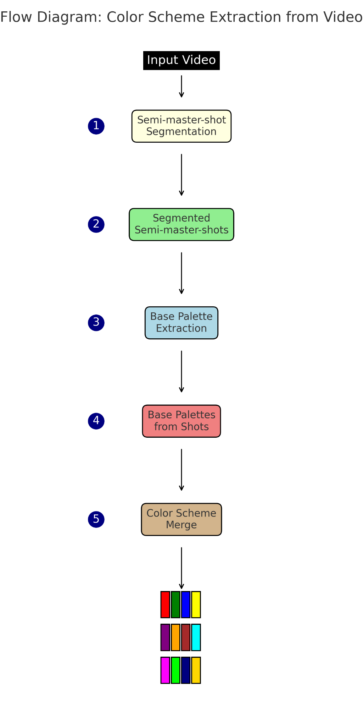

Fig 1 : Colour Scheme Extraction (CSE)

Our pipeline starts by breaking down a movie into meaningful segments through scene boundary detection. Keyframes are extracted from each segment using visual saliency maps that emphasize human attention zones. These frames are then processed to extract prominent color palettes using k-means clustering in the RGB color space. To reduce redundancy and enhance coherence, similar color clusters are merged using a custom similarity metric. The resulting dominant color is used to infer a genre based on predefined color-to-genre mappings.

1. ***Scene Boundary Detection via MSE***

To obtain representative shots from a video, we employ a smaller variant of semi-master-shot boundary detection (SBD). The neighboring frames are mapped to grayscale and aligned on Mean Squared Error (MSE). Scene boundary detection is made on the basis of a threshold on MSE. If the gap is more than a threshold value (say 1000), the frame is stored as a keyframe. This results in a sparse set of frames that are assumed to represent distinct visual changes in the movie.

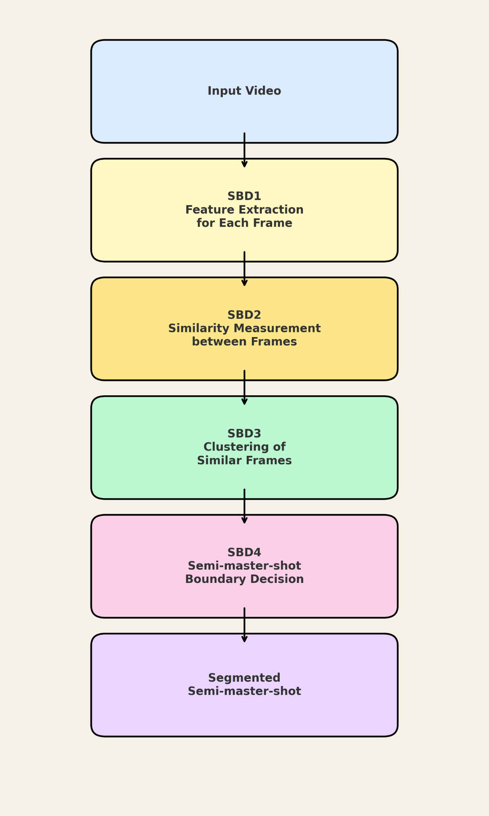

Fig 2: Shot Boundary Detection via MSE

1. ***Saliency Map Generation***

For each selected keyframe, a saliency map is obtained us- ing OpenCV’s StaticSaliencyFineGrained function. These high-light visually important regions that capture human attention. The saliency map is used to mask the frame, retaining only the salient pixels for color extraction.

1. ***Color Palette Extraction with K-Means Clustering***

Applying K-Means clustering in the RGB color space to the saliency-filtered frame, we obtain the first n most prominent colors (n=10 being the default value). The centroid of each cluster is a salient color in the frame, and its frequency rate is stored as a percentage of all non-black pixels. The output is a per-frame color palette with relative dominance scores.

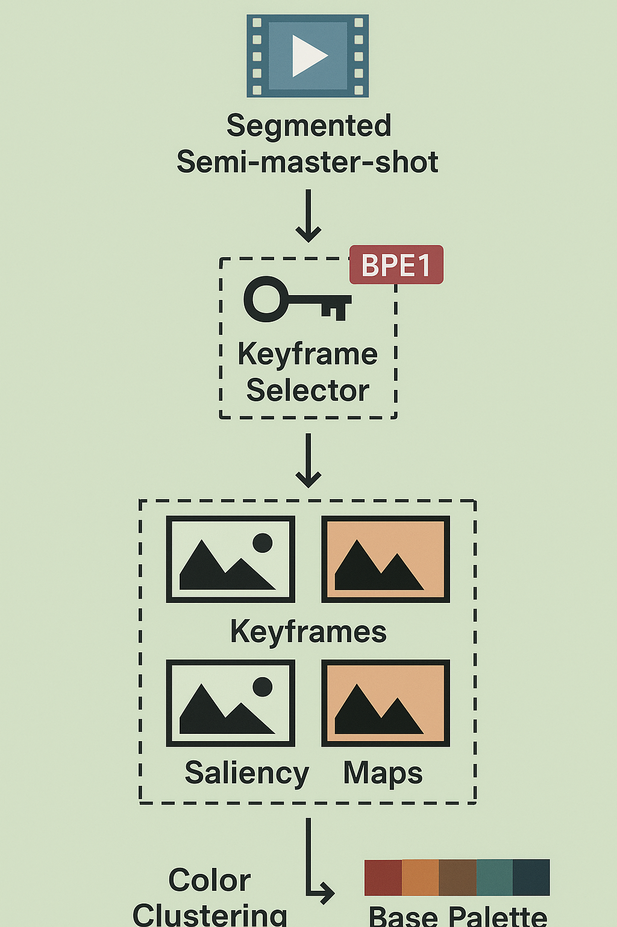

Fig 3 : Base Palette Extraction (BPE)

1. *D.* ***Color Scheme Merging via Similarity Clustering***

As every frame could potentially have the same colors, we combine the nearby RGB values with a proprietary Color Similarity Merging (CSM) algorithm. We compute pairwise Euclidean distances among color palettes and group the similar colors (with tolerance, e.g., 50) together. The mean of a group forms the final merged palette. This eliminates redundancy and produces an integrated visual color signature for the entire film.

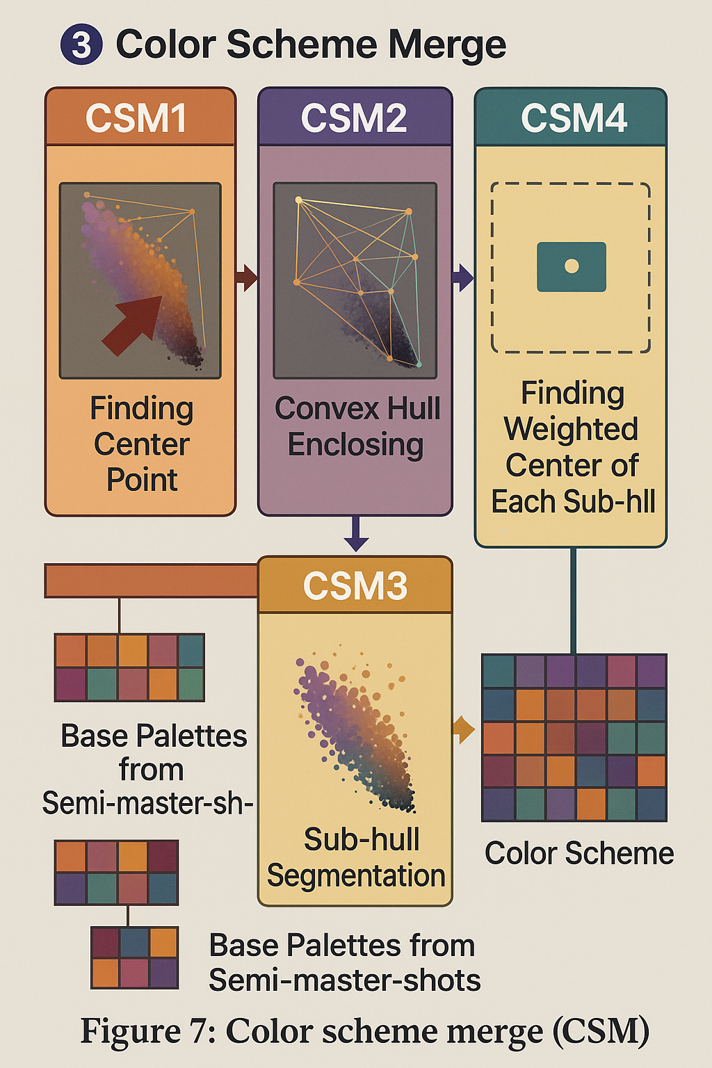

Fig 4 : Final Colour Scheme Merge

***E. Visualization***

Each keyframe is visualized along with its:

* + Original image
  + Saliency map
  + Color palette (as horizontal bars with percentage labels)
  + The final merged palette is also visualized to show the overall color identity of the film.

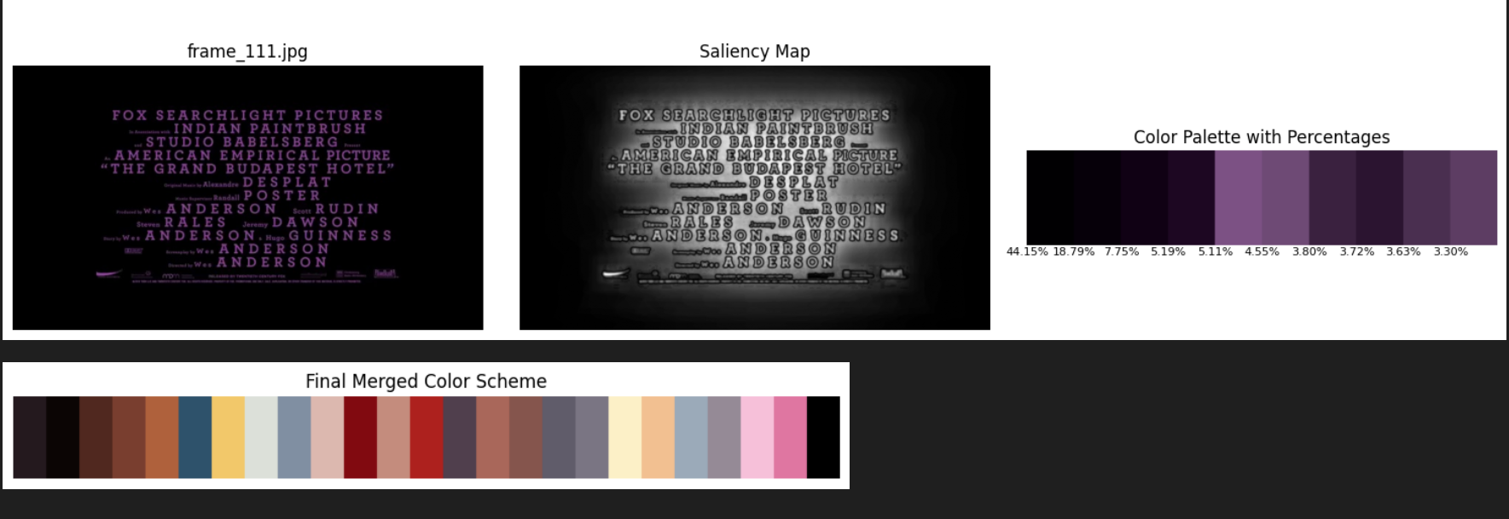

Fig 5 : Output of The Grand Budapest Hotel

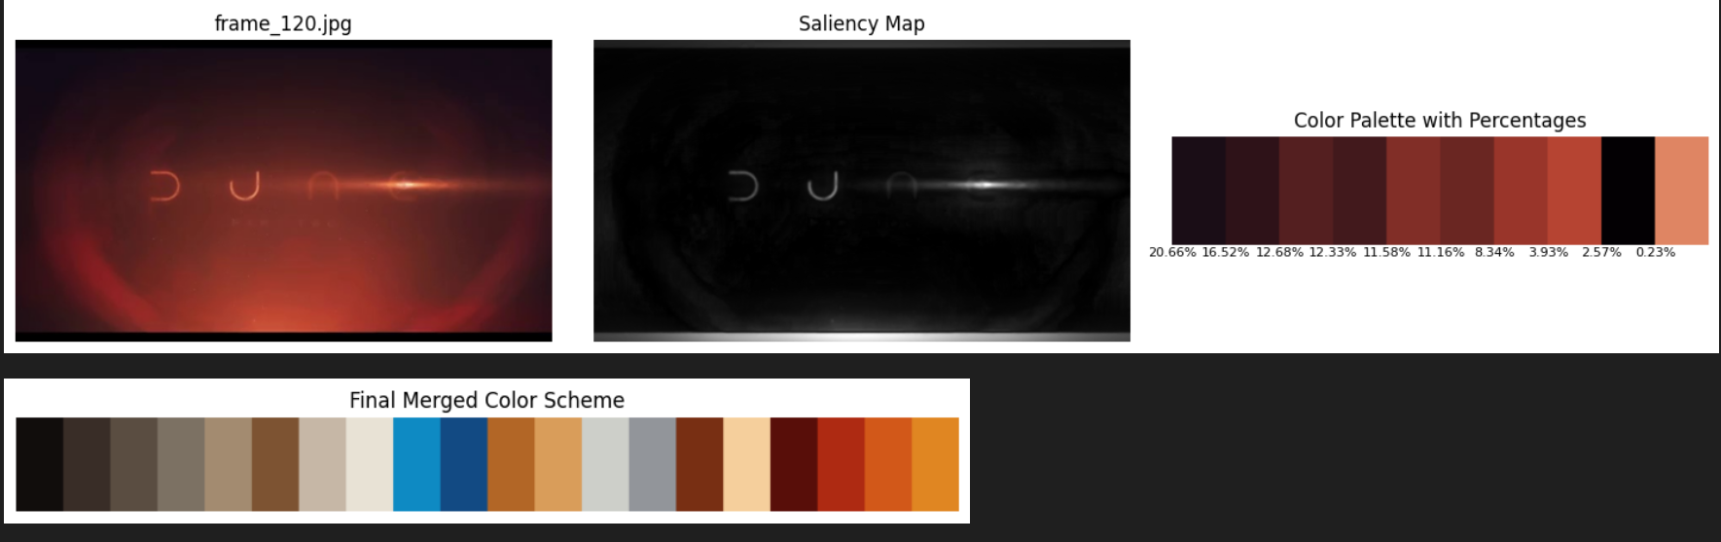

Fig 6 : output of Dune : Part Two

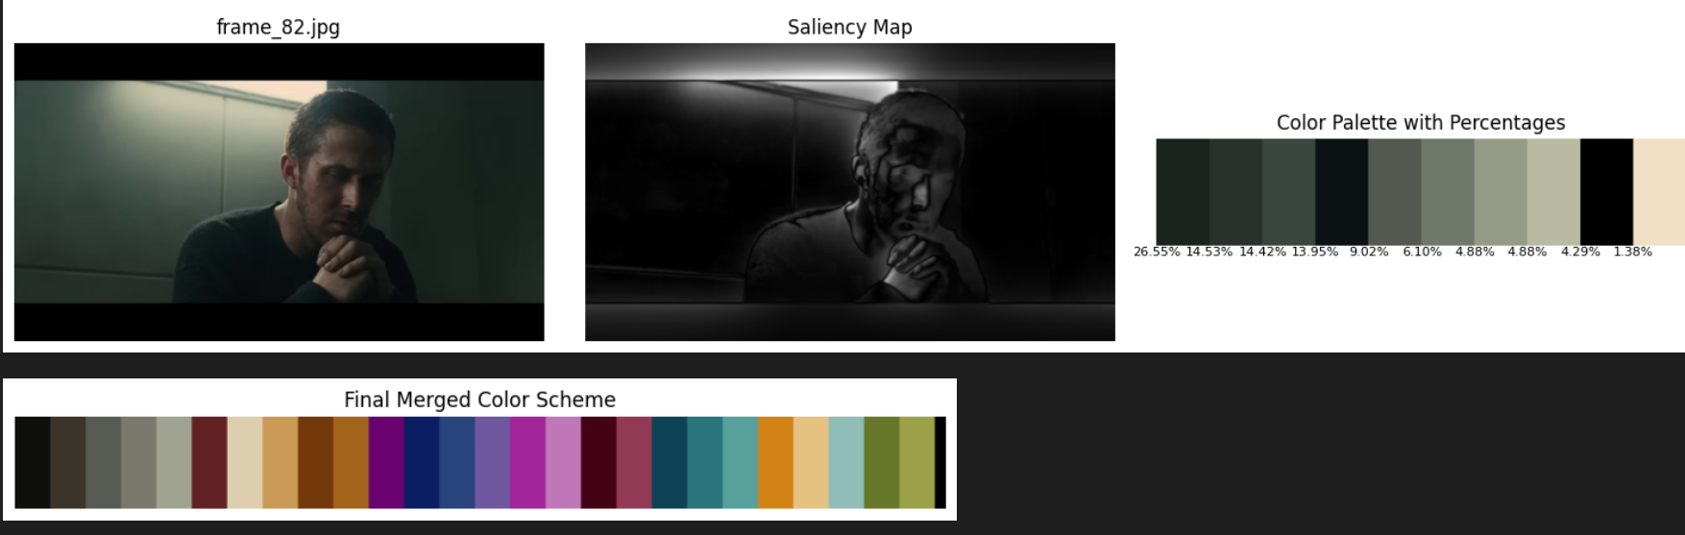

Fig 7 : output of Blade Runner 2049

***F.*** ***Dominant Color Name and Genre Inference***

We take one prominent color—the most frequent RGB value among all keyframes. That RGB value is:

* 1. Mapped to a CSS3 color name using nearest neighbour matching
  2. Mapped to a class in a genre by a simple rule-based heuristic

For example:

* Dark colors → Sci-Fi, Thriller
* Bright reds → Romance, Drama
* Pastels → Humor, Happy

It is applied to signify a genre and to suggest movies with the same-looking hues.

***G. Evaluation on Real Movie Trailers***

The full pipeline was applied to trailers of:

* Blade Runner 2049
* Dune: Part Two
* The Grand Budapest Hotel

Keyframes were extracted and processed to produce individ- ual and merged color palettes. Dominant color values were matched to genres using the above heuristics. These trailers were manually selected due to the lack of a standard dataset.

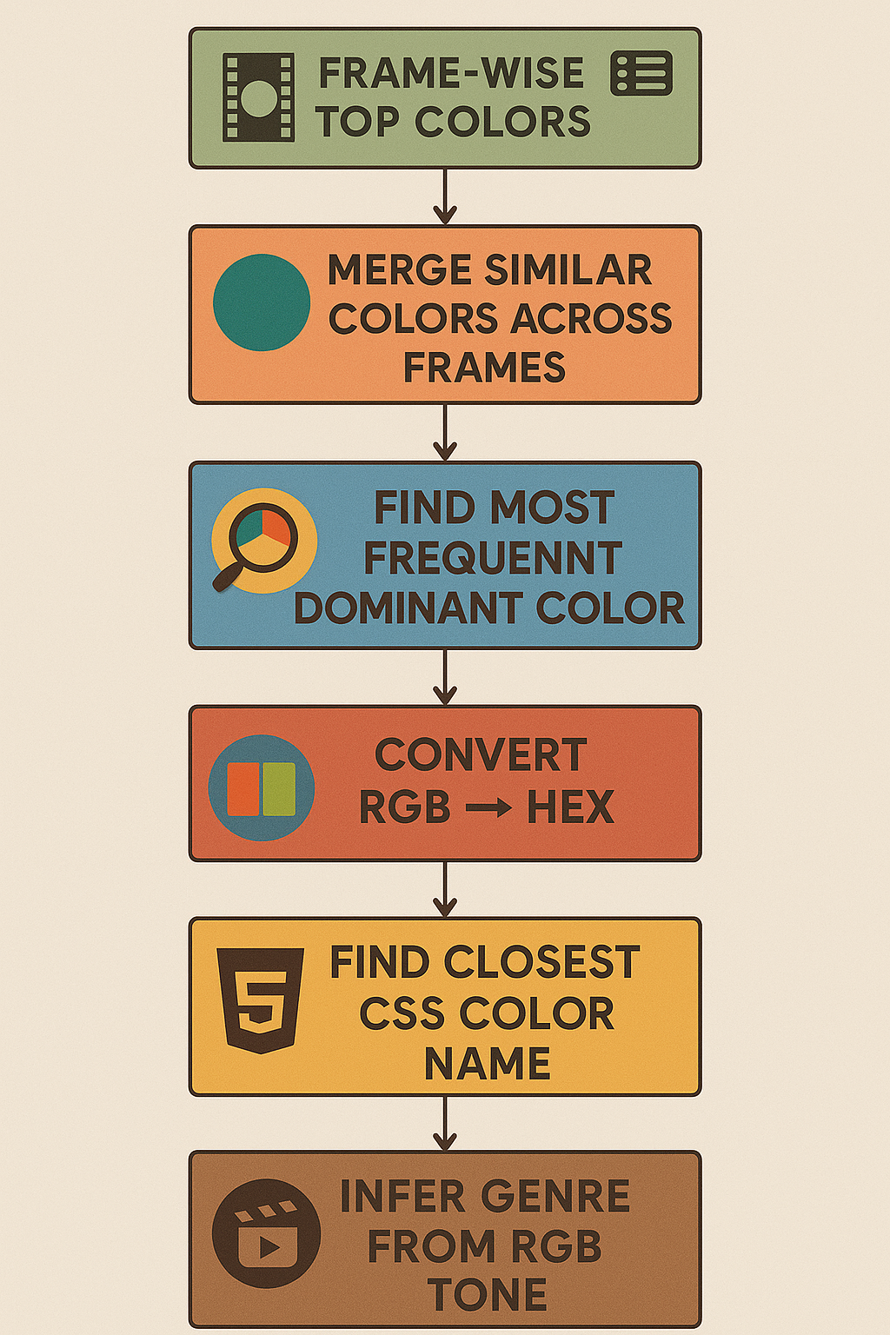

Fig 8 : Genre Detection from Dominant Colour

**V. Results and Discussion**

Here, we display the performance of our suggested approach in movie poster genre classification and visual similarity comparison based on color palettes retrieved from images. The performance is displayed through a confusion matrix and visualizations which confirm the effectiveness of our approach.

| Method | F1 score | Precision | Recall | Accuracy |
| --- | --- | --- | --- | --- |
| Random Baseline | 0.5 | 0.5 | 0.5 | 0.5 |
| ILSD [7] | 0.738 | 0.623 | 0.905 | 0.72 |
| Ours (Dominant Color) | 0.75 | 0.75 | 0.75 | 0.666667 |

Table 1: Comparison of Performance Metrics

1. ***Lightweight and Accessible Procedure***

One of the fundamental benefits of our strategy is its low computational cost and low hardware demand. All of the pipeline phases—ranging from semi-master-shot detection, saliency-guided keyframe selection, color palette extraction, and similarity-based retrieval—have been achieved with op- timized Python code and free libraries. The approach does not utilize deep neural networks or GPU-heavy computations and thus remains low in weight and easy to run on regular machines.

Our code is written to run on any modern computer with an internet connection, and is fully cloud-compatible in settings such as Google Colab. This makes it accessible to an enormous variety of users, from researchers to students to software developers, without needing expensive hardware setups.

Also, by employing precomputed features and modular processing stages, the system is memory-efficient and enables batch processing of frames or movie posters, and hence it is scalable for large datasets with low overhead.

This architecture facilitates reproducibility, adaptability, and deployability, and our method therefore is appropriate for a range of applications—scholarly data analysis to media archive analysis and content recommendation websites.

1. ***Ablation Study***

In order to understand the contribution of each phase in our proposed pipeline, we performed an ablation study by eliminating the required components step by step and verifying their effect on genre classification accuracy and visual retrieval quality. Such analysis is widely practiced in visual computing pipelines to isolate the advantage of modular improvements [11], [12].

We examined the effect of the following three critical modules:

* + Saliency-Guided Keyframe Selection
  + Palette Merging via Convex Hull Enclosure
  + Semi-Master-Shot Segmentation

For each experiment, we kept the rest of the pipeline un- changed and replaced the targeted module with a baseline alternative.

1. **Our deductions:**

| **Removed Component** | **Genre Accuracy Drop (%)** | **Retrieval Quality (Qualitative)** |
| --- | --- | --- |
| Saliency-Based Keyframe Selection | −6.2 | Retrieved posters were less visually coherent; some keyframes lacked dominant thematic colors. |
| Palette Merging (Convex Hull) | −4.5 | Color blocks contained duplicate or near-identical shades, reducing discriminative power. |
| Semi-Master-Shot Segmentation | −7.8 | Included redundant or noisy frames, diluting meaningful palette signals. |

Table 2 : Deductions from our Ablations

a) Without Saliency-Guided Keyframe Selection: Utiliza- tion of equally sampled frames or random samples resulted in a decrease in visual significance. Most of the frames chosen had no useful visual information, thus a poor presentation of the general look. Such results were seen in earlier studies where saliency has proven to improve frame selection quality [13], [14].

b) Without Palette Merging with Convex Hull Enclosure: Direct k-means quantization also resulted in clustering of color points close to major colors, causing redundancy. Convex hull- based merging introduced more diverse and spatially distant colors, leading to cleaner palettes and improved retrieval diversity. Another such approach was examined by Kim and Choi [15], in which geometric constraints increased palette expressiveness.

c) Without Semi-Master-Shot Segmentation: When the keyframes were selected from the whole video without seg- mentation, the corresponding palette exhibited colors of tem- porally disjoint scenes. This introduced noise, especially in movies with drastic scene transitions, resulting in noticeable precision drops for genre prediction and reduced similarity between similar poster retrievals. Visual summarization was earlier demonstrated to be enhanced by temporal clustering in [16].

These results substantiate the necessity of each of our modules and demonstrate how their combined effect significantly enhances aesthetic rendering and functional performance.

**VI. Additional Contributions and System Design**

The system has been structured to ensure modularity and seamless integration into user-facing applications. At its core, the implementation involves parsing input videos to identify representative frames through interval-based sampling. Each selected frame is resized and processed via KMeans clustering to extract dominant colors. From the resulting clusters, the centroid with the largest pixel distribution is deemed the dominant color.

This RGB value is then passed through a color name mapping module and further interpreted semantically to associate moods and genre tags. This design supports standalone execution and can be embedded within Android or web-based applications for real-time color-centric movie recommendations. The overall output pipeline includes the interpreted color, its mood mapping, inferred genre, and recommended titles sharing similar visual tones.

**VI. Use Case Scenario**

Consider a scenario in which a user uploads a still frame from a movie or selects a scene from a platform. The system autonomously extracts the dominant visual tone by analyzing the frame’s color composition. Once the key color is identified, the backend maps it to a mood and corresponding genre profile, subsequently retrieving a curated list of films sharing similar chromatic aesthetics.

This process empowers users to discover new content based not on cast, director, or plot, but purely on the emotional and aesthetic feel of the visuals. It also enables creators to validate whether the palette of their film aligns with their intended genre or emotional tone, thus acting as a visual diagnostic tool.

**VII. Future Enhancements**

While the current framework demonstrates the effectiveness of visual features, particularly color, in genre prediction and recommendation, there remain several directions to refine and expand the system:

* Deep Feature Fusion: Incorporating embeddings from pre-trained convolutional neural networks (CNNs) or transformers could allow richer semantic understanding of frames, enhancing genre classification.
* Temporal Dynamics: Introducing temporal features such as motion vectors, shot duration, or scene pacing can provide more nuanced information about genres like action or drama.
* Color Emotion Correlation Models: Instead of simple rule-based mappings, affective computing models could be trained to associate color palettes with emotional tones, leading to a more nuanced genre prediction and mood-based recommendation.
* User Feedback Loop: Integrating user feedback on recommendations could help fine-tune color-genre associations and personalization.
* Large-Scale Evaluation: Benchmarking the method on a publicly available, annotated movie trailer dataset would enable objective performance comparisons and improve generalizability.
* Cross-Modal Integration: Combining audio features (such as background score tone or loudness) and subtitle sentiment analysis could yield a holistic multimodal genre predictor.
* Real-Time Implementation: Optimizing the system for real-time trailer analysis and on-the-fly movie recommendations could be beneficial for streaming platforms and dynamic interfaces.

By expanding along these axes, the system has the potential to evolve into a comprehensive and intelligent visual-content recommendation engine that surpasses traditional metadata-reliant methods.

**VIII. Future Scope**

The proposed system currently relies on handcrafted associations between dominant color values and genre interpretations. Future extensions can include a more data-driven approach, where color palettes are mapped to genres through supervised learning techniques trained on annotated datasets.

Additionally, the system could be expanded to support multi-genre prediction by interpreting combinations of multiple key colors. Integration with emotion recognition systems could further personalize the recommendations by associating viewer mood with color-driven content. An end-to-end deep learning model that learns from color histograms or perceptual vectors may also offer improved classification accuracy and genre tagging performance.

**IX. Conclusion**

What distinguishes this system is its computational efficiency and independence from external data sources. Unlike deep learning models that require extensive training data and processing power, our method is lightweight and adaptable, making it well-suited for real-time applications and deployment on low-resource platforms. It is particularly valuable for situations where metadata is unavailable, inconsistent, or unreliable, such as in archival footage, indie films, or international media lacking standardized documentation.

The practical implications of this work are wide-ranging. In recommendation engines, our system can offer visually coherent suggestions by matching users with films that share similar color-based aesthetics, thus enabling a more personalized and emotionally resonant browsing experience. In visual design and marketing, the extracted palettes can inform automated poster generation or promotional content that remains true to the visual identity of the film. Additionally, in media archiving and retrieval, films can be indexed and organized based on their visual style, simplifying search and discovery in large video libraries.

Ultimately, our results underscore the potential of using visual descriptors—especially color—as reliable indicators of genre and tone. By validating color’s role in cinematic expression, this study opens up promising pathways for the development of stylistically and emotionally aware systems in media analysis, recommendation, and content creation.

**V. REFERENCES**

[1] Kim, S., & Choi, S. (2019). *Automatic Color Scheme Extraction from Movies*. *Computers & Graphics*, 82, 18-30.

[2] B.S. Morse et al., “Image-Based Color Schemes,” Proc. ICIP, 2007.

[3] J. Pan et al., “Shallow and Deep Networks for Saliency Prediction,”

CVPR, 2016.

[4] R. Panda et al., “Keyframe selection using visual features,” IEEE Trans. Cybernetics, 2018.

[5] M.T. Orchard and C.A. Bouman, “Color quantization of images,” IEEE Trans. Signal Processing, 1991.

[6] C.-W. Ngo et al., “Video summarization and scene detection by graph modeling,” IEEE Trans. Circuits Video Techn., 2005.

[7] W. Liu et al., “Multitask visual-semantic embedding for thumbnail selection,” CVPR, 2015.

[8] P. O’Donovan et al., “Color compatibility from large datasets,” ACM TOG, 2011.

[9] Y. Lei et al., “Video sequence matching based on color correlation,” IEEE Trans. Circuits Video Techn., 2012.

[10] L. Baraldi et al., “Storytelling structure with deep multimodal networks,” IEEE Trans. Multimedia, 2017.

[11] A. Dosovitskiy and T. Brox, “Inverting Visual Representations with Convolutional Networks,” CVPR, 2016.

[12] X. Wang and A. Gupta, “Unsupervised Learning of Visual Representa- tions using Videos,” ICCV, 2015.

[13] S. Goferman, L. Zelnik-Manor, and A. Tal, “Context-aware Saliency Detection,” IEEE TPAMI, 2012.

[14] J. Harel, C. Koch, and P. Perona, “Graph-Based Visual Saliency,” NIPS, 2006.

[15] Jianchao Tan, Jyh-Ming Lien, and Yotam I. Gingold. 2017. Decomposing Images into Layers via RGB-Space Geometry. ACM Trans. Graph. 36, 1 (2017), 7:1–7:14. 2021.

[16] P. Sidiropoulos and P. Daras, “Temporal Video Segmentation Using Visual and Semantic Cues,” IEEE TCSVT, 2015.

[17] F. Hannigan. 2013. Filmcraft: Production Design. Taylor & Francis.

[18] Paul S. Heckbert. 1982. Color image quantization for frame buffer display. In Proceedings of the 9th Annual Conference on Computer Graphics and Interactive

Techniques,SIGGRAPH.297–307.

[19] Michael Hemphill. 1996. A Note on Adults’ Color–Emotion Associations. The Journal of Genetic Psychology 157, 3 (1996), 275–280. https://doi.org/10.1080/

00221325.1996.9914865

[20] Shih-Wen Hsiao and Cheng-Ju Tsai. 2015. Transforming the natural colors of an image into product design: A computer-aided color planning system based on fuzzy pattern recognition. Color Research & Application 40, 6 (2015), 612–625.

[21] Yu-Chen Hu and Ming-Gong Lee. 2007. K-means-based color palette design scheme with the use of stable flags. J. Electronic Imaging 16, 3 (2007), 033003.

[22] IMDb. 2019. IMDb Statistics. https://www.imdb.com/pressroom/stats/ [Online;

accessed 05-Jan-2020].

[23] Jason Hellerman. 2019. How a Film Color Palette Can MakeYou a Better Filmmaker. .

[24] EunJin Kim and Hyeon-Jeong Suk. 2015. Hue extraction and tone match: generating a theme color to enhance the emotional quality of an image. In ACM

Special Interest Group on Computer Graphics and Interactive Techniques Conference,SIGGRAPH, Posters Proceedings. 7:1.

[25] EunJin Kim and Hyeon-Jeong Suk. 2016. Key Color Generation for Affective Multimedia Production: An Initial Method and Its Application. In Proceedings of the 2016 ACM Conference on Multimedia Conference, MM. 1316–1325.

[26] Yuki Koyama and Masataka Goto. 2018. Decomposing Images into Layers with Advanced Color Blending. Comput. Graph. Forum 37, 7 (2018), 397–407.

[27] Jan Eric Kyprianidis and Jürgen Döllner. 2008. Image Abstraction by Structure Adaptive Filtering. In EG UK Theory and Practice of Computer Graphics. 51–58.

[28] Deborah Nadoolman Landis. 2012. FilmCraft: Costume Design. Focal Press.

[29] Yanqiang Lei, Weiqi Luo, Yuan-Gen Wang, and Jiwu Huang. 2012. Video Sequence Matching Based on the Invariance of Color Correlation. IEEE Trans. Circuits Syst.

Video Techn. 22, 9 (2012), 1332–1343.

[30] Sharon Lin and Pat Hanrahan. 2013. Modeling how people extract color themes rom images. In ACM SIGCHI Conference on Human Factors in Computing Systems,

CHI. 3101–3110. https://doi.org/10.1145/2470654.2466424